67-jenkins-into to 77th

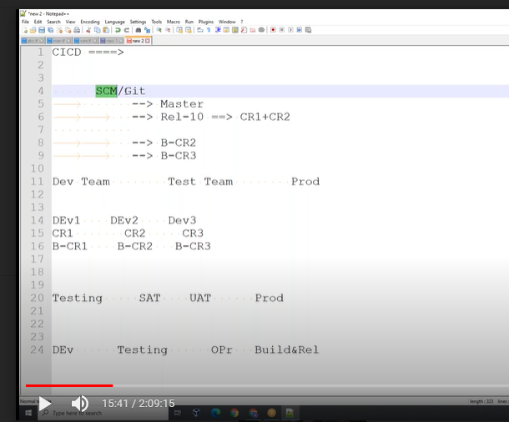

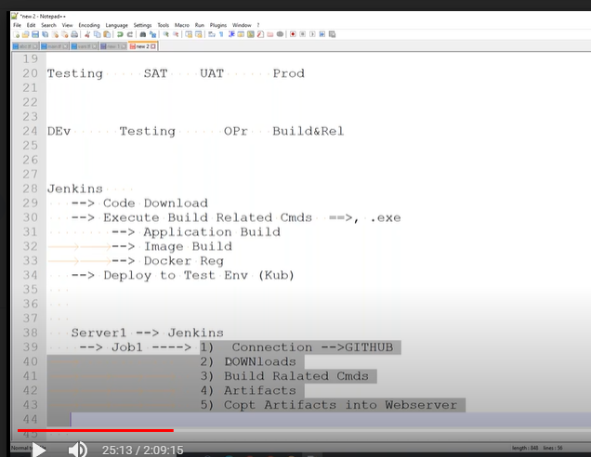

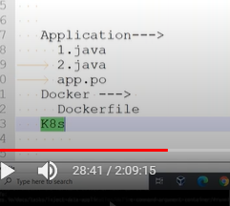

Ci/cd—process steps below

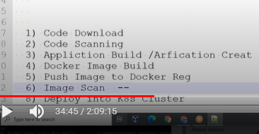

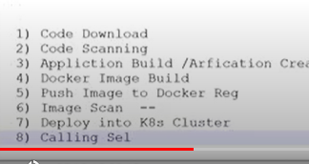

Branching sttagiy

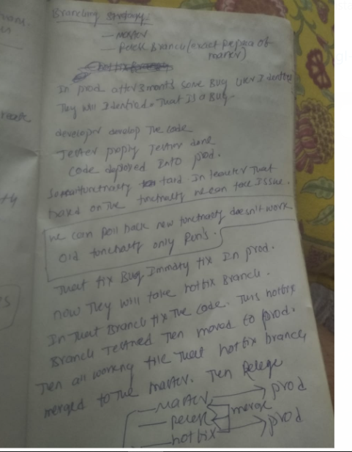

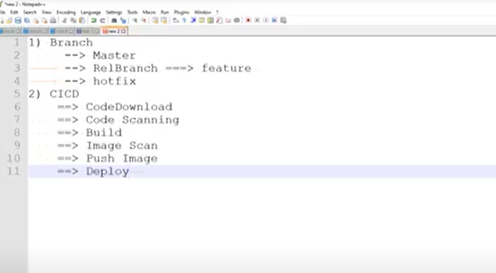

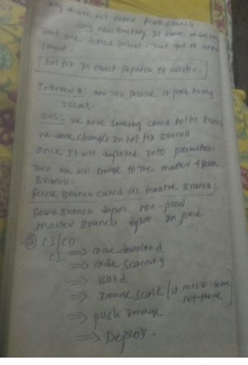

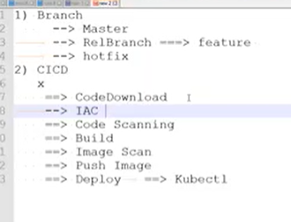

Install Jenkins

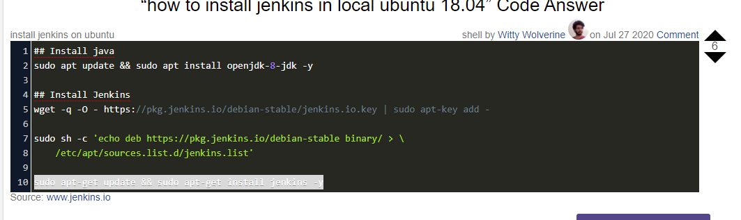

## Install java

sudo apt update && sudo apt install openjdk-8-jdk -y

## Install Jenkins

wget -q -O - https://pkg.jenkins.io/debian-stable/jenkins.io.key | sudo apt-key add -

sudo sh -c 'echo deb https://pkg.jenkins.io/debian-stable binary/ > \

/etc/apt/sources.list.d/jenkins.list'

sudo apt-get update && sudo apt-get install jenkins

service Jenkins status

588dbba3f3624c50836a3906621d916d

master will shudled your job in slave machine

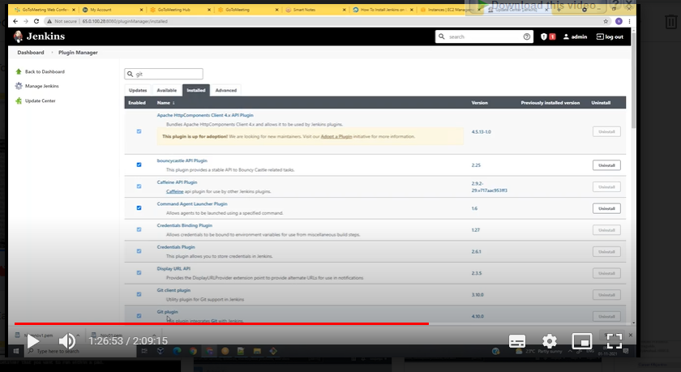

Prient env: environment variable’s

Build number nothing but the job name.

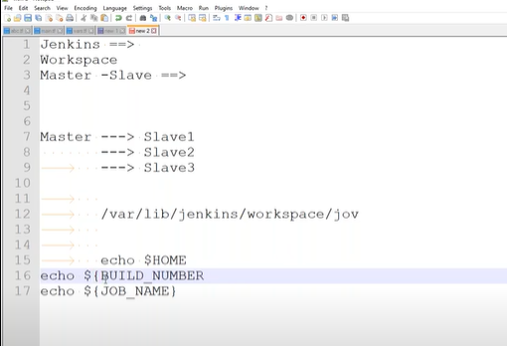

pwd

echo this is my first jon

cp /etc/passwd .

whoami

echo ${var_1}

if 1st command failed it is not goto 2nd command.

./1.sh

ca-certificates \

curl \

gnupg \

lsb-release

curl -fsSL https://download.docker.com/linux/ubuntu/gpg | sudo gpg --dearmor -o /usr/share/keyrings/docker-archive-keyring.gpg

echo \

"deb [arch=$(dpkg --print-architecture) signed-by=/usr/share/keyrings/docker-archive-keyring.gpg] https://download.docker.com/linux/ubuntu \

$(lsb_release -cs) stable" | sudo tee /etc/apt/sources.list.d/docker.list > /dev/null

sudo apt-get update

sudo apt-get install docker-ce docker-ce-cli containerd.io

**we can put all code into one file 1.sh**

**we are having one-job multiple builds**

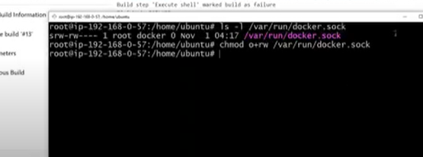 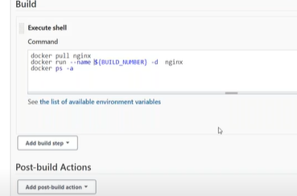

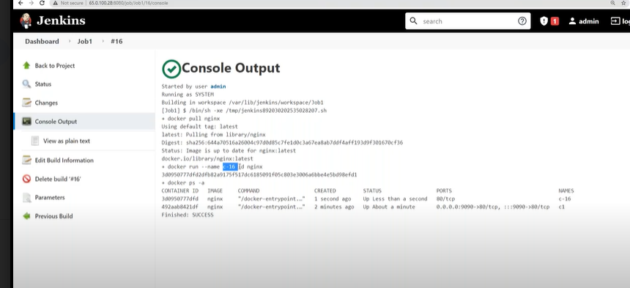

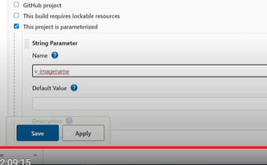

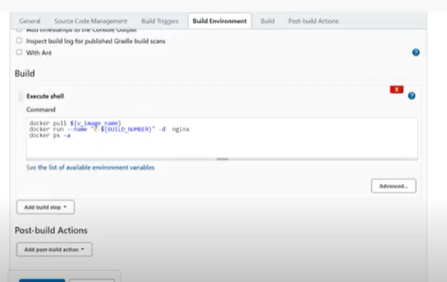

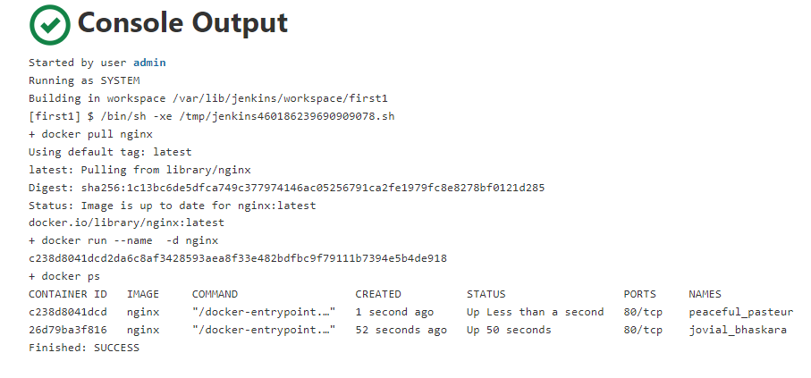

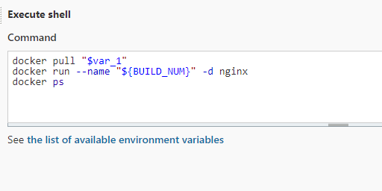

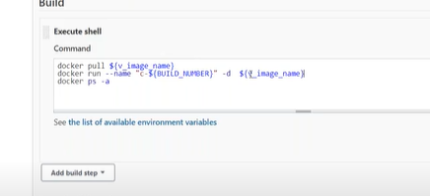

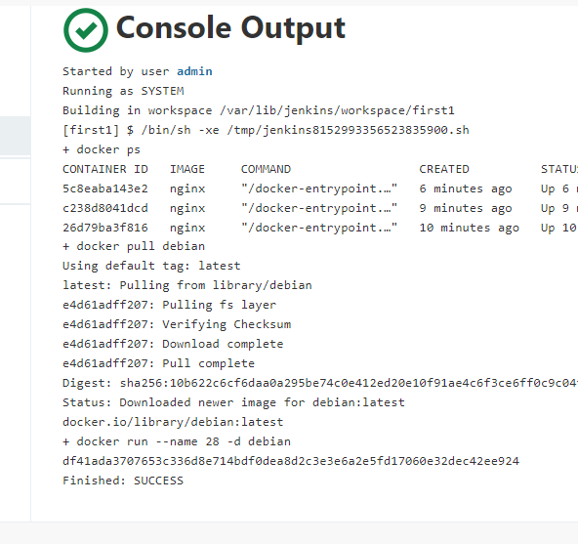

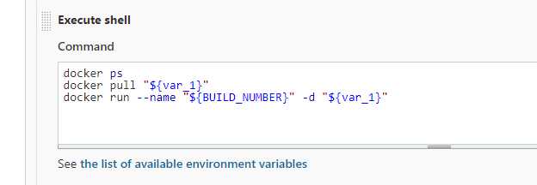

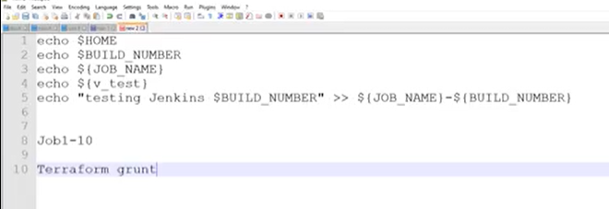

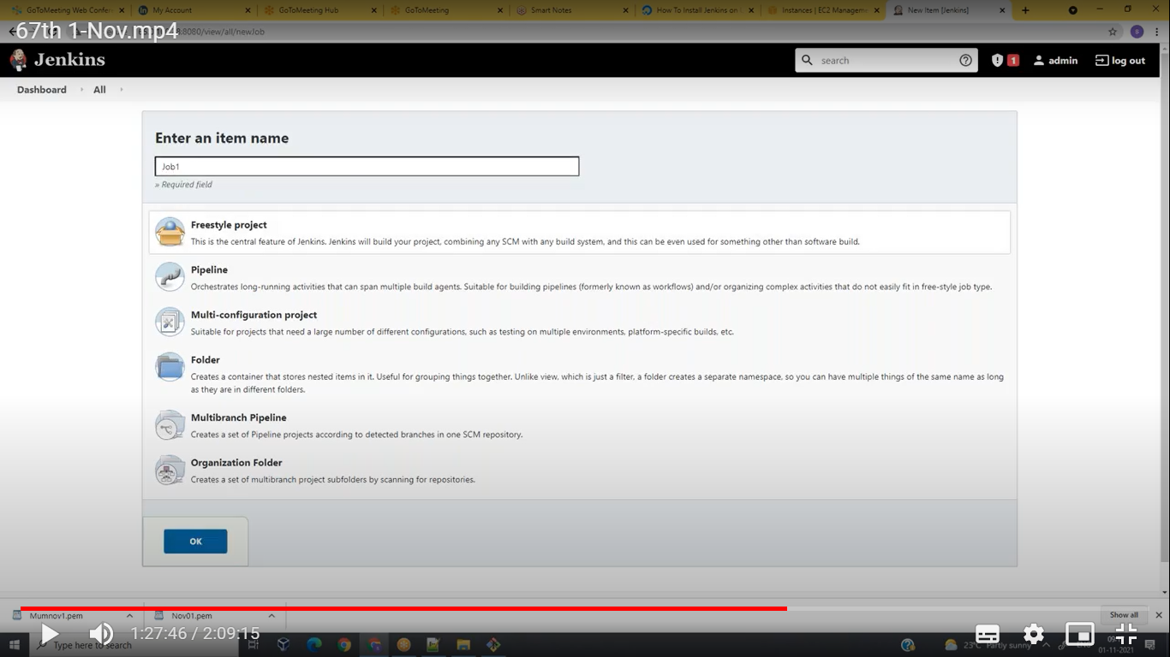

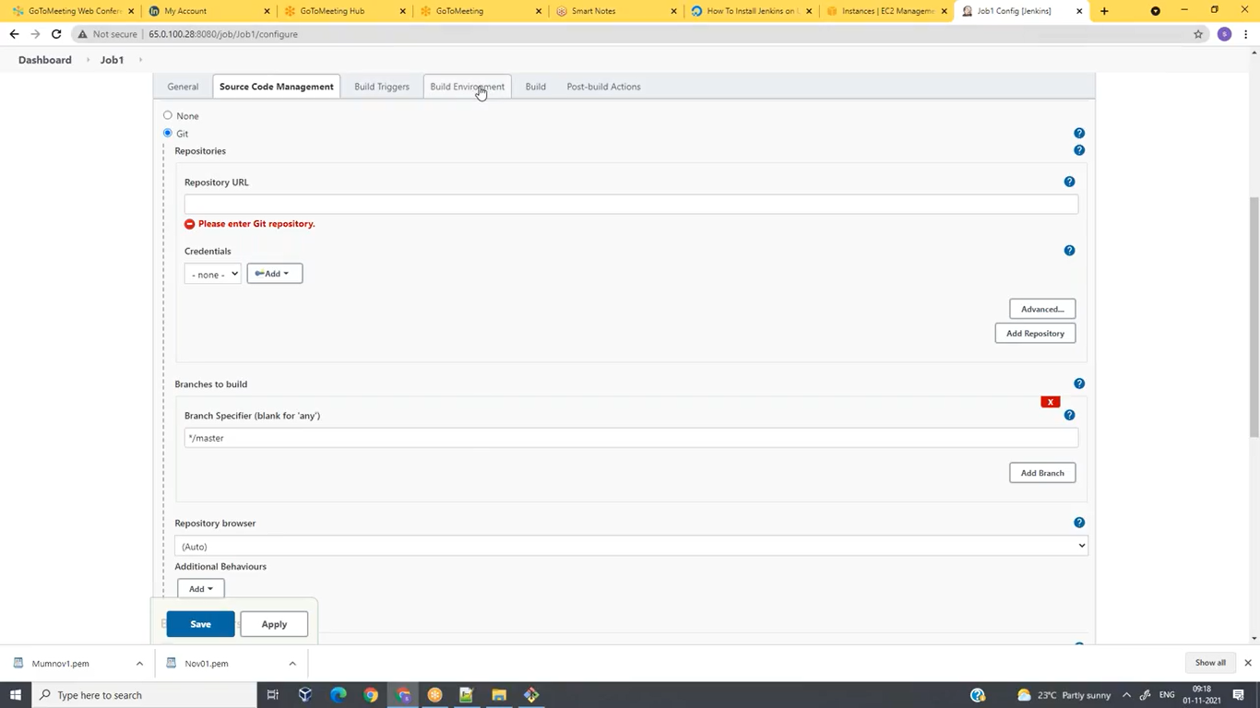

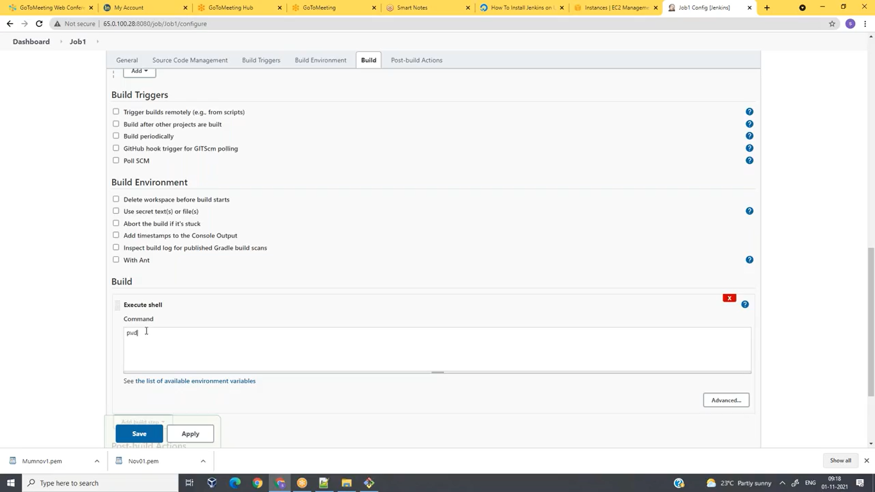

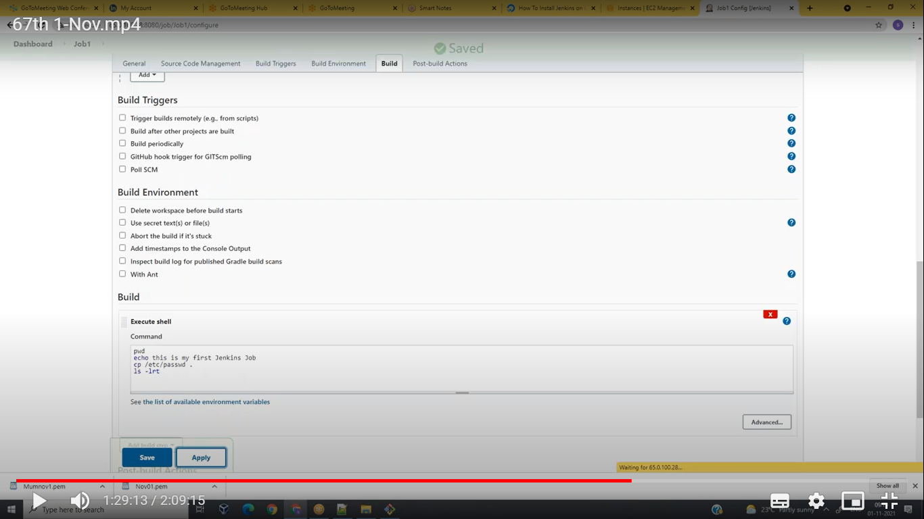

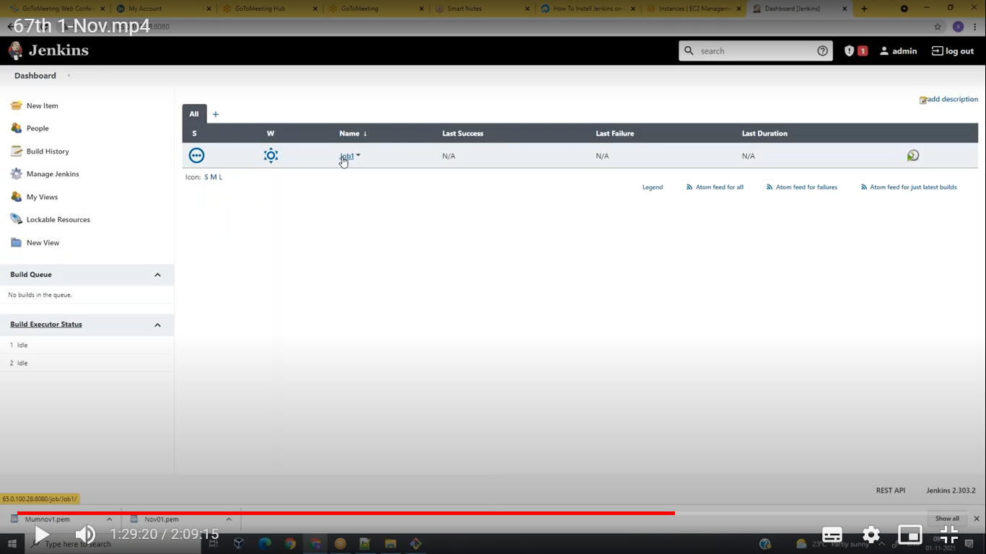

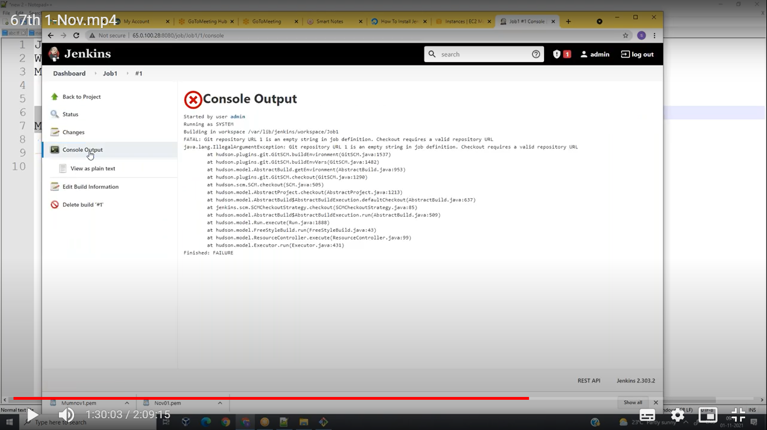

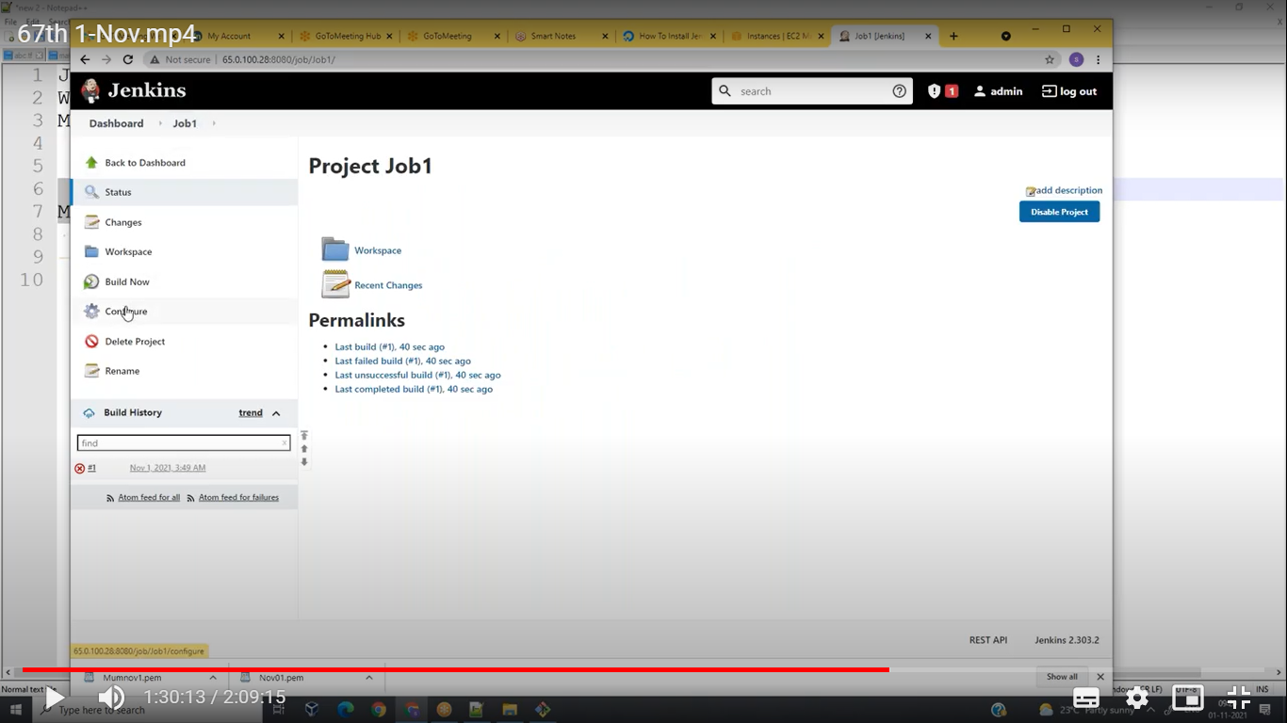

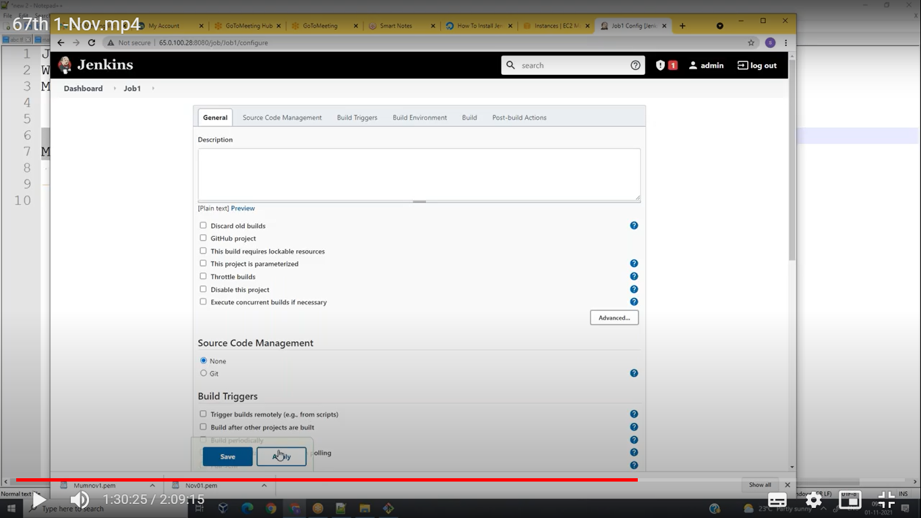 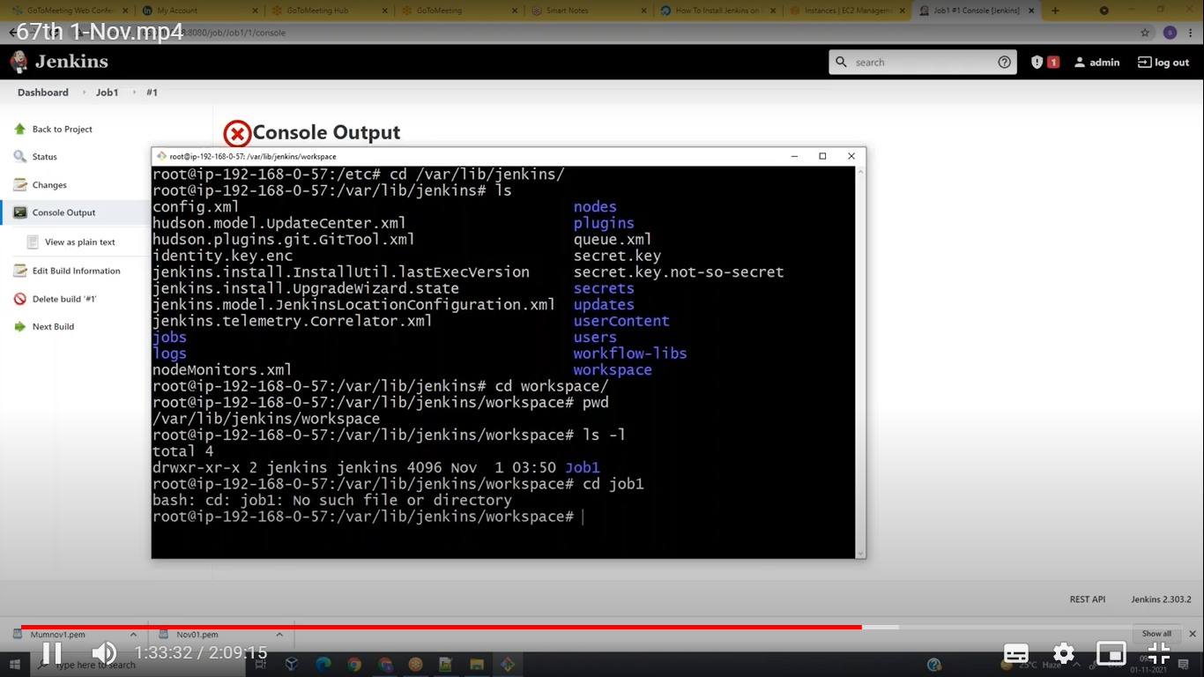

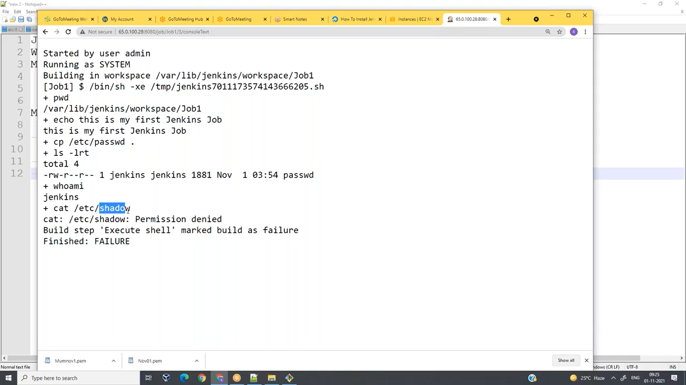

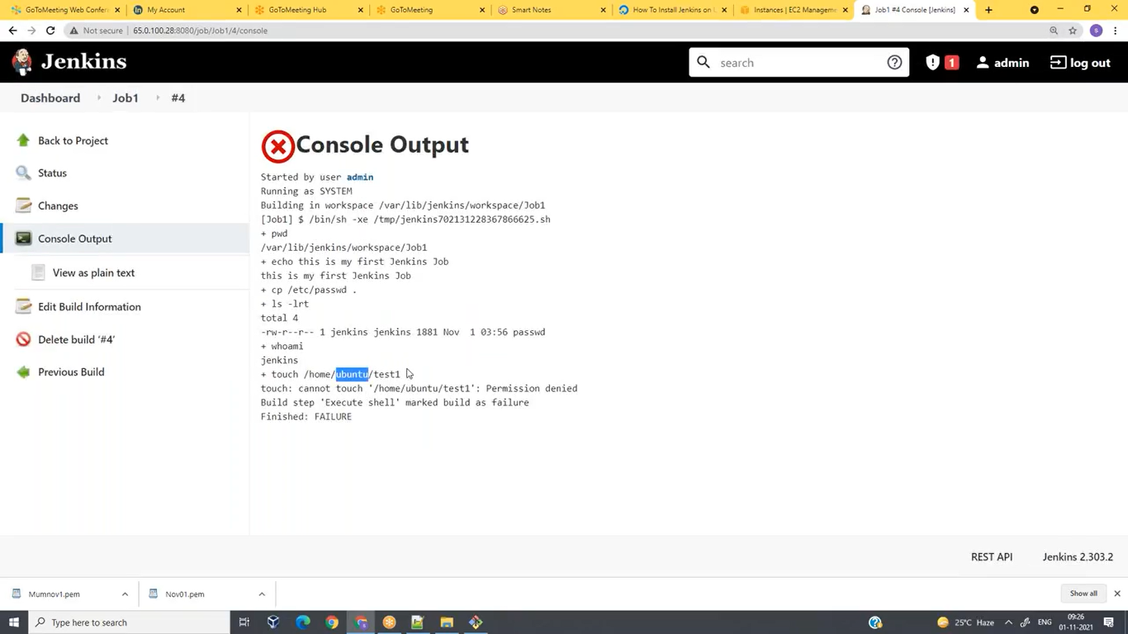

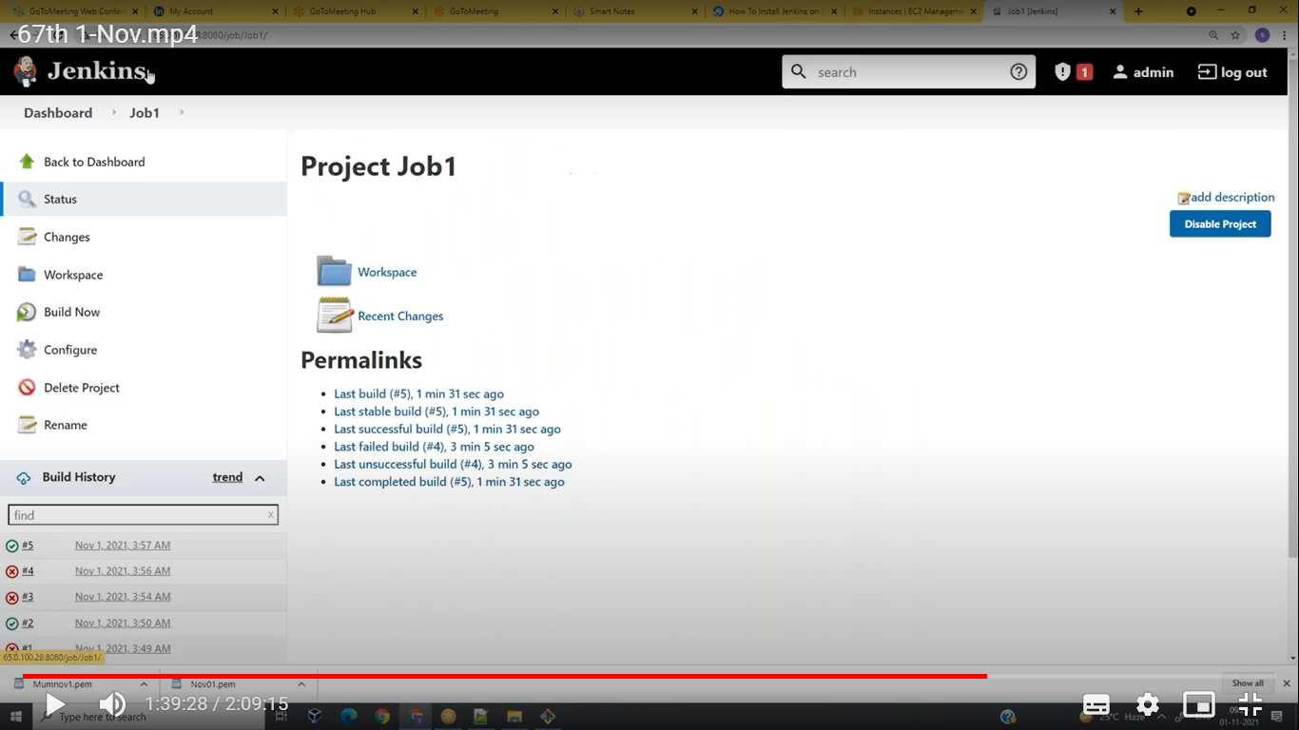

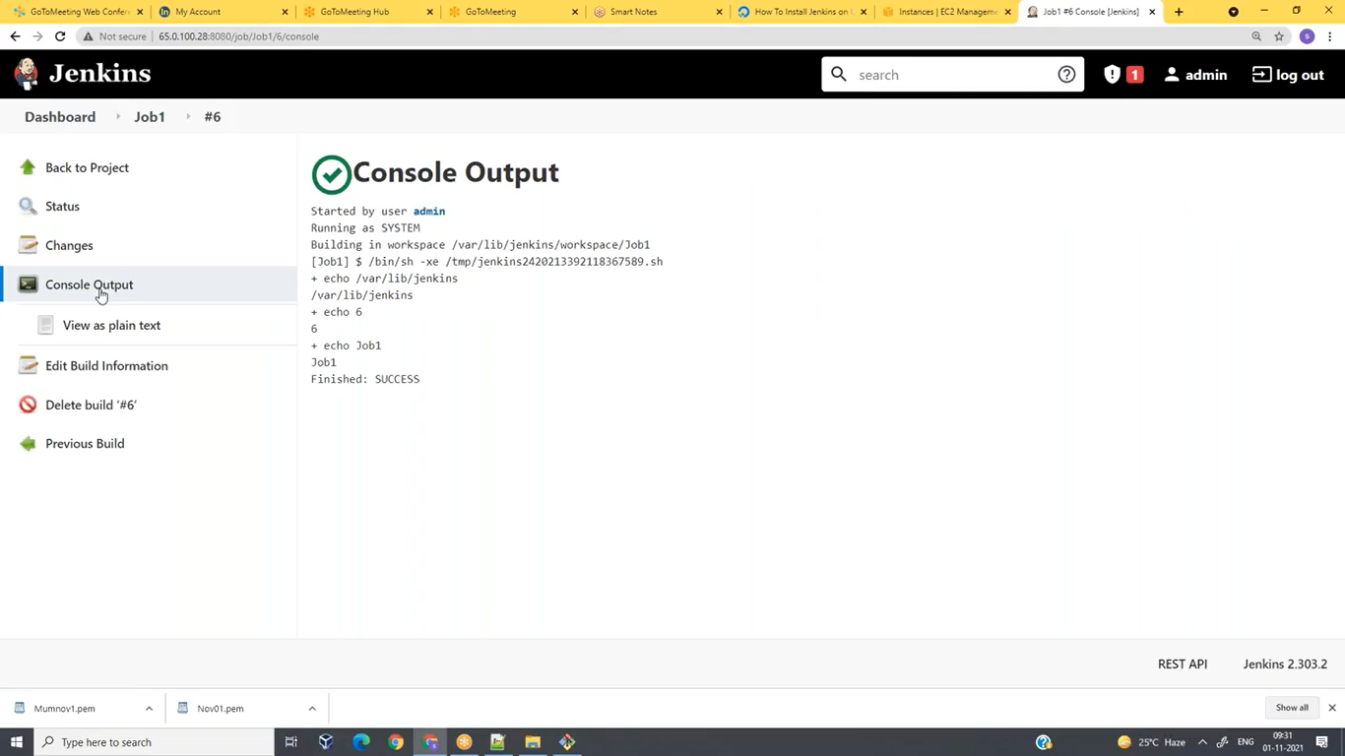

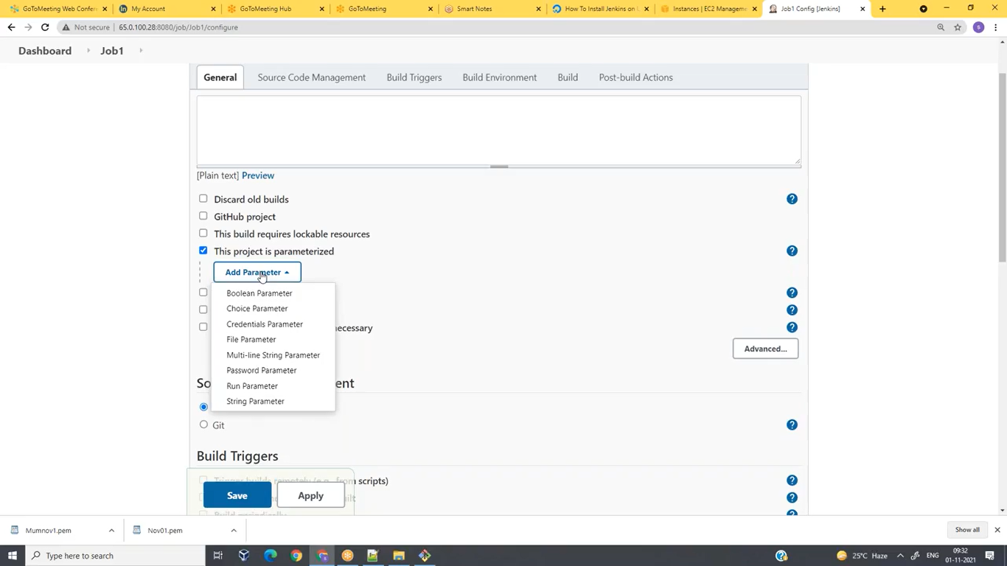

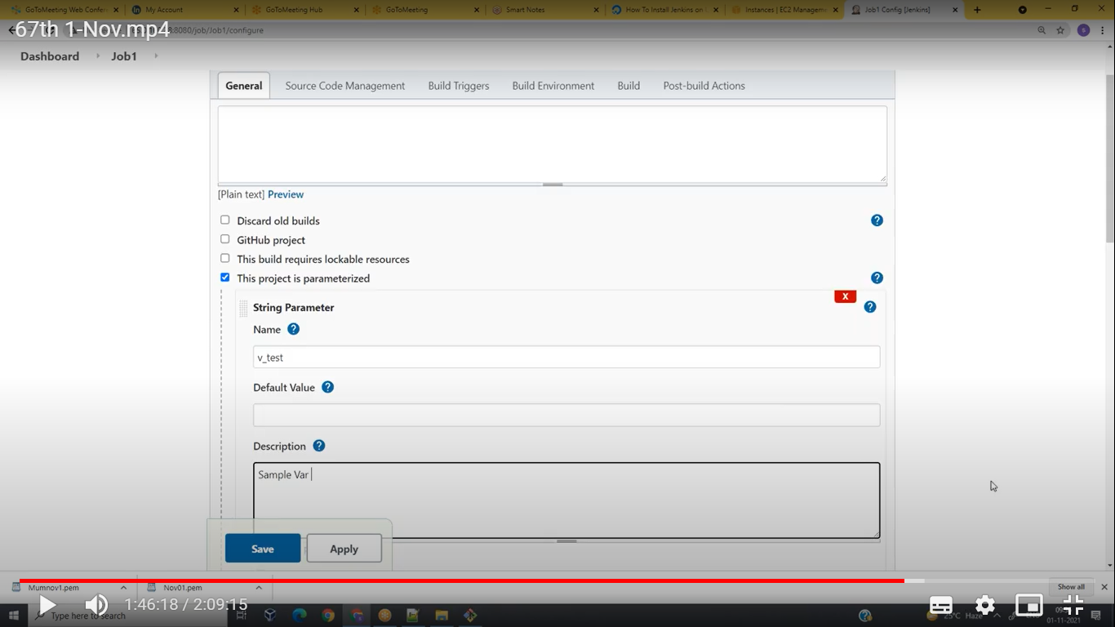

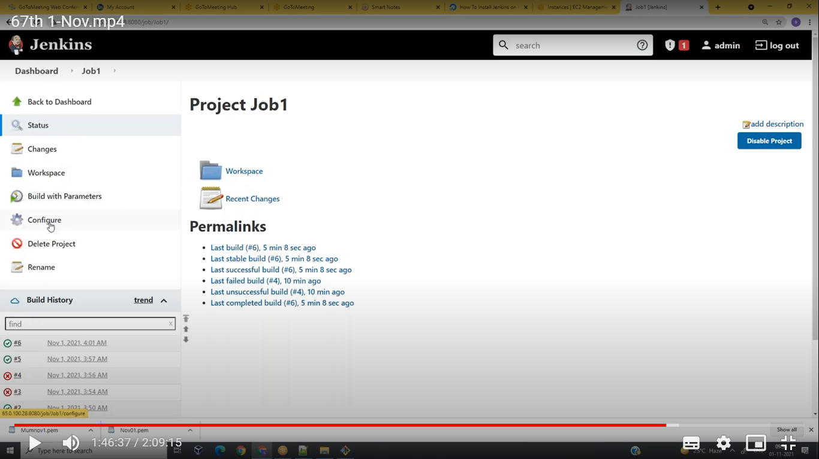

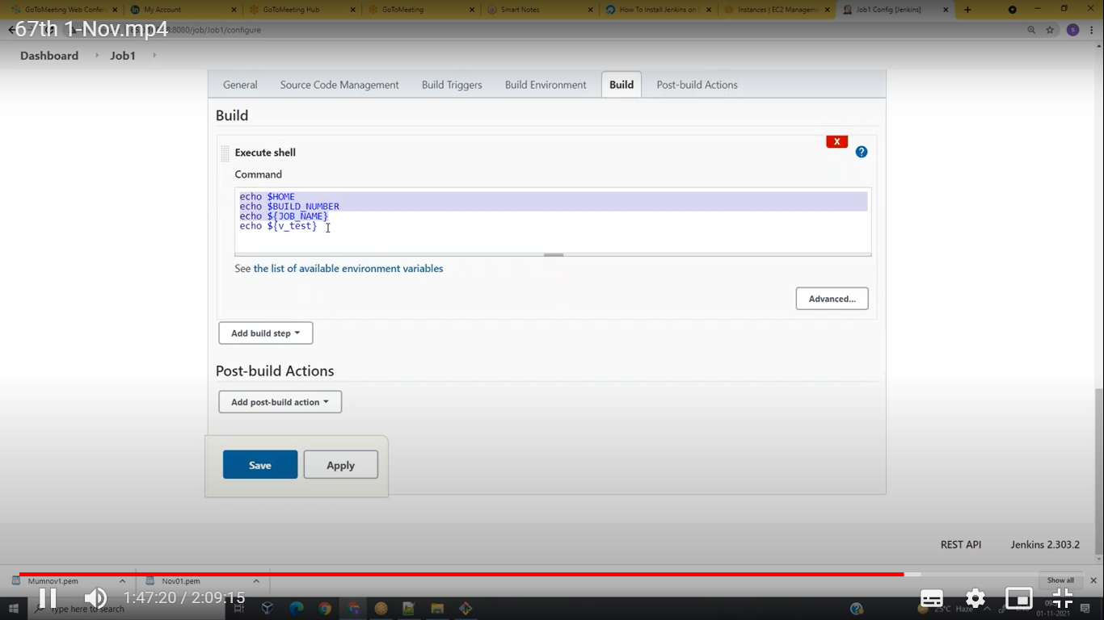

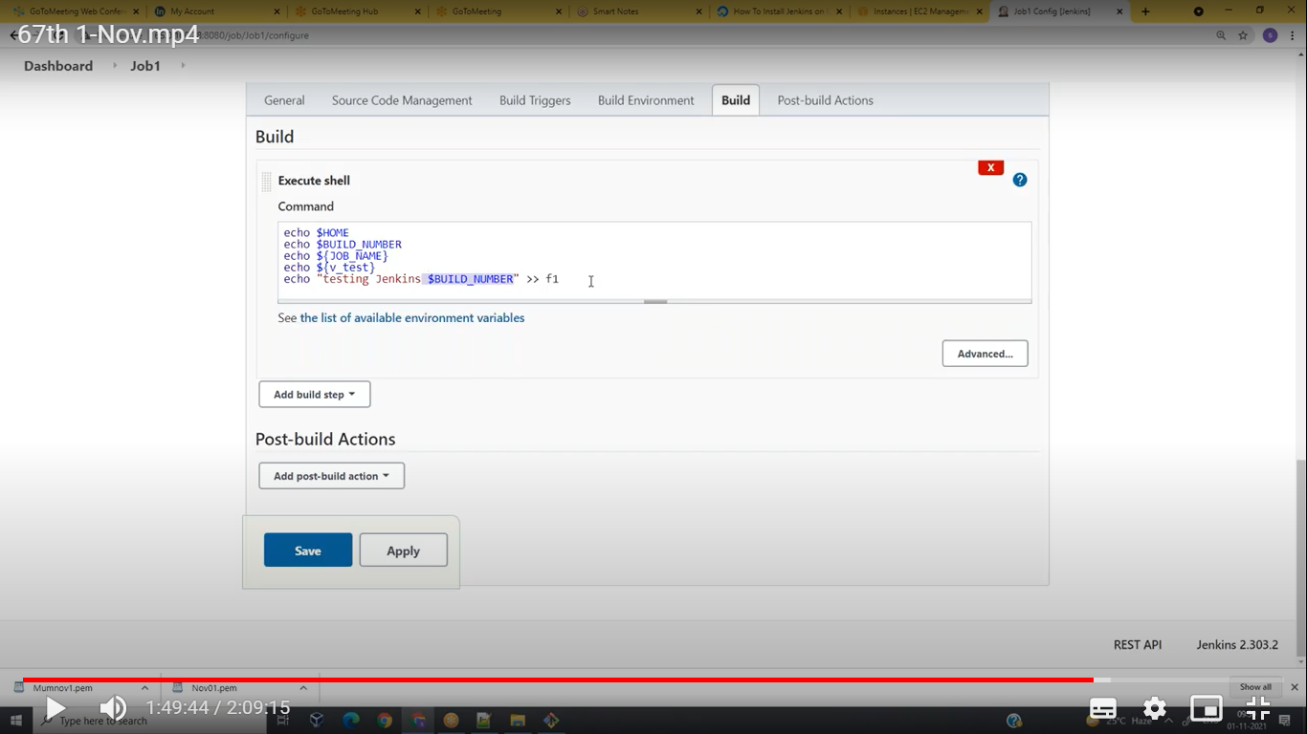

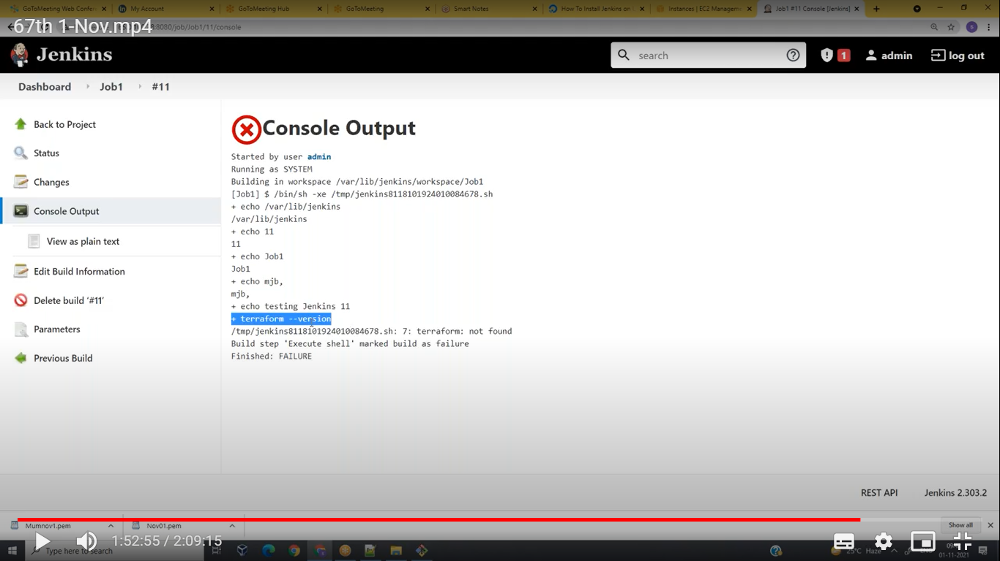

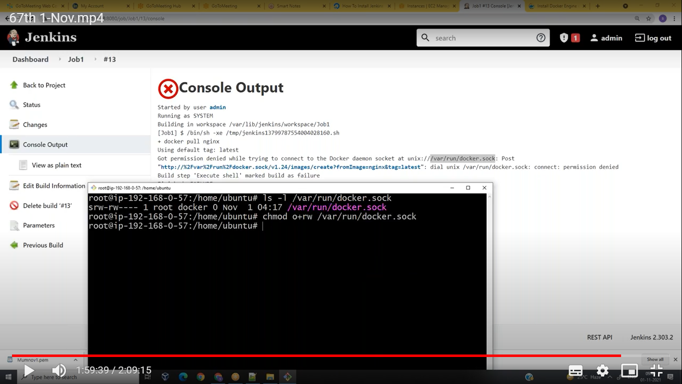

**16Pq5@0306**

**Git init**

**Git add f1**

**Git commit -m “added f1”**

**Git branch -M main**

**Git remote add origin https://**

**Git push -u origin main**

**Git init: create a local repo**

**Git add filename: add file’s statging area to working area**

**Git commit: pusg file’s from working area to local repo**

**Git remote add origin http:: add the github repo to machine**

**Git push -u origin master: push the code to git remote repo.**

**Git remote -v**

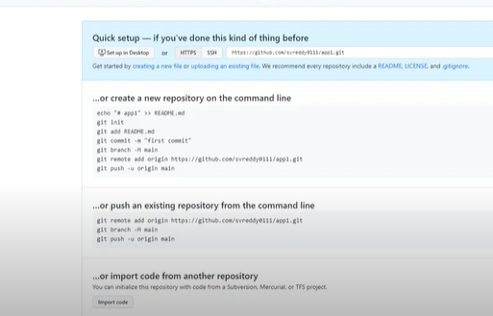

Gsumanth1996

Dinnu918273

git push -u origin HEAD:master

Git branch rel-1: create the branch

Master branch excat replica is rel-1

Git branch: checking the branches

$ cat Dockerfile

FROM openjdk

WORKDIR /app

COPY * .class .

CMD ["java","HelloWorld"]

We are push the rel-1 branch code to github

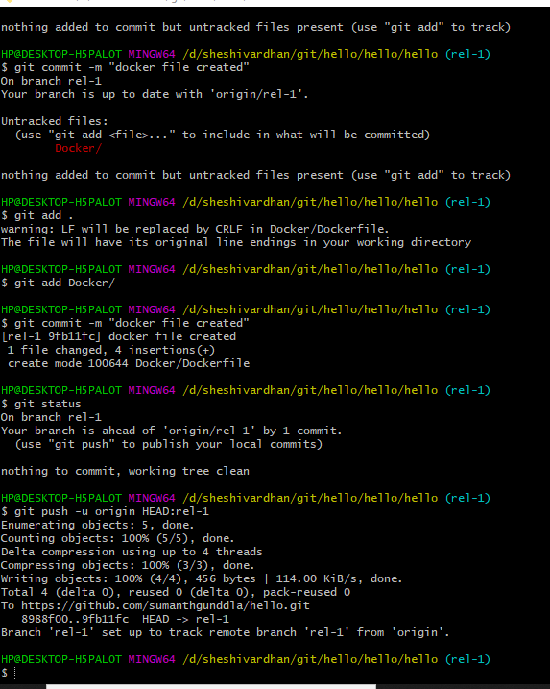

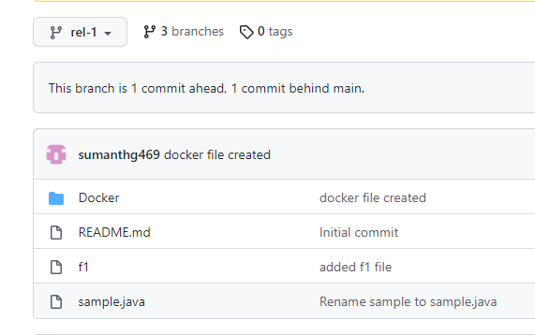

Ls -lrtR(recurisve in side dir file’s also it will shown)

Orkspace clean before excution or clone the git repo

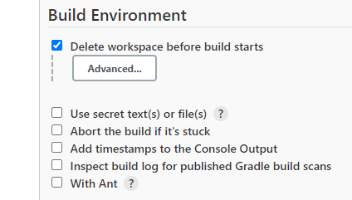

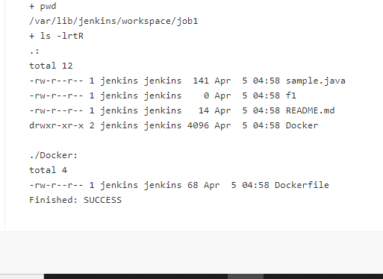

Cleaned before excution build.

1. Build with parameter
2. Git hub
3. Configure
4. Clean the before build excution.

Docker build -t jdk .

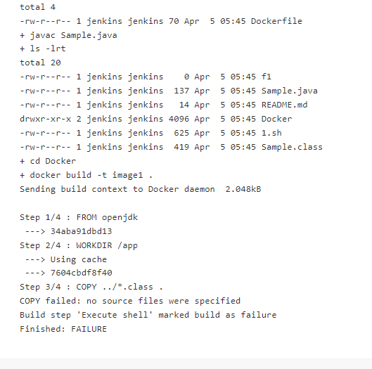

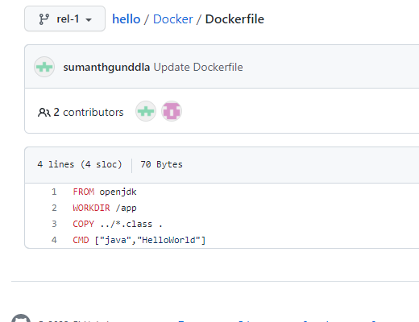

We wrote docker file like that it will give the error.

No source file is there

${BUILD-NUMBER}

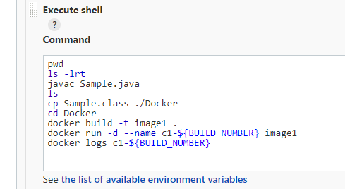

At the time excuting build it will ask branch name input

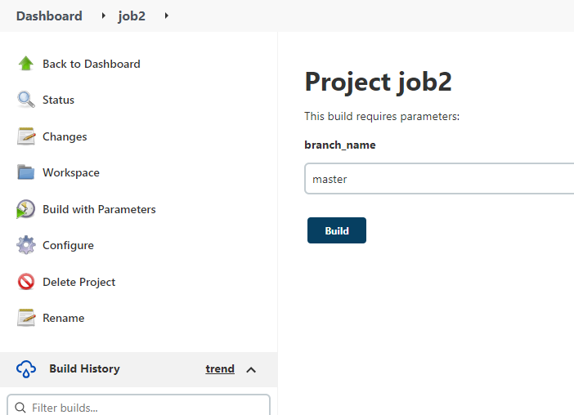

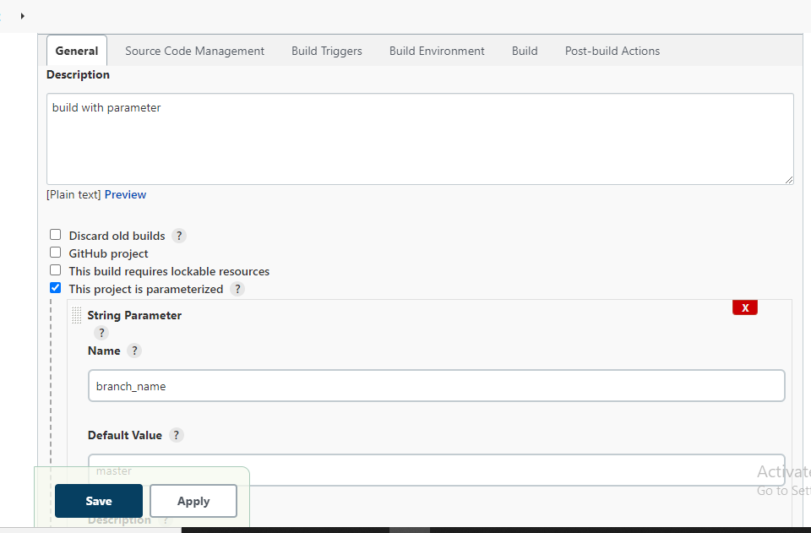

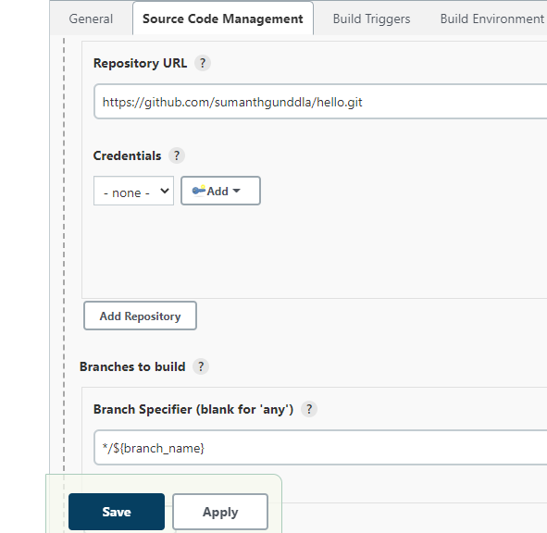

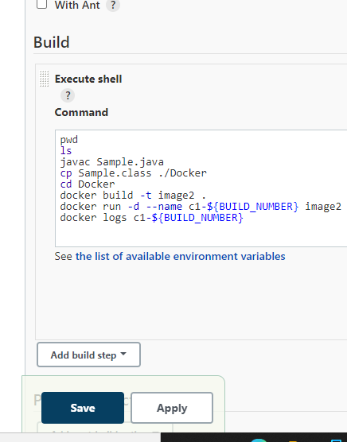

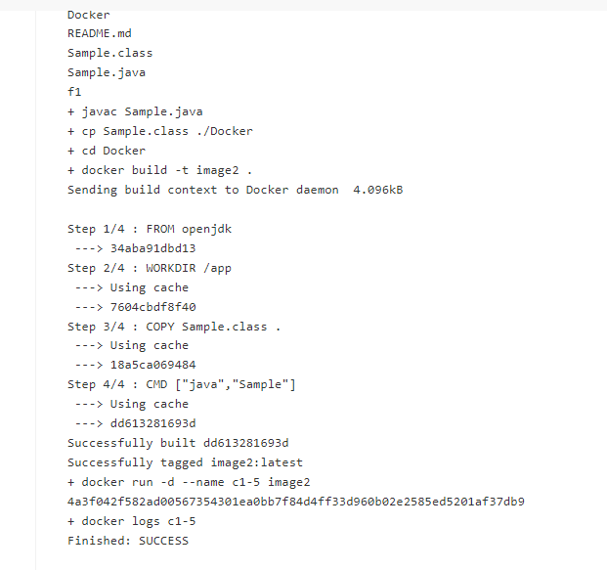

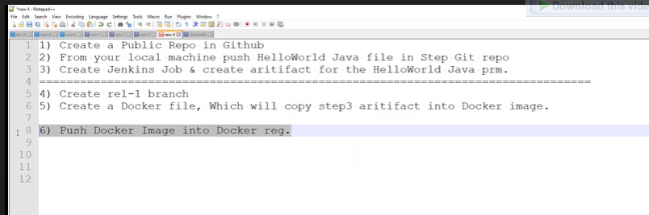

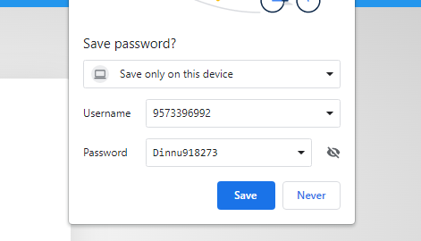

[Gsumanth1996@gmail.com](mailto:Gsumanth1996@gmail.com)

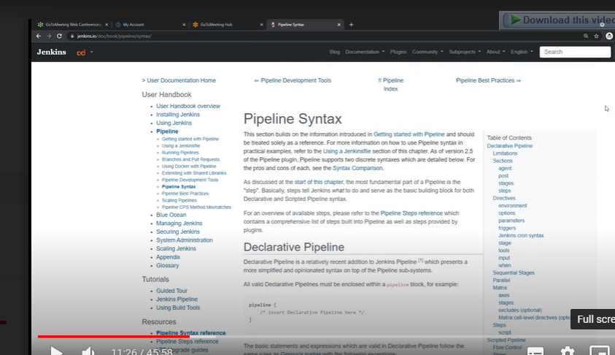

窗体顶端

Description



**Visibility**

Using 0 of 1 private repositories. **[Get more](https://hub.docker.com/billing/plan/update)**



**Public**

Appears in Docker Hub search results



**Private**

Only visible to you

CancelCreate

窗体底端

Pro tip

You can push a new image to this repository using the CLI

docker tag local-image:tagname new-repo:tagname  
docker push new-repo:tagname

We are having image’s storing we have multiple repo’s

Docker hub

Ecr

Azure

Ggoglecloud

Docker.io/username/repogistory(imagename):tahname

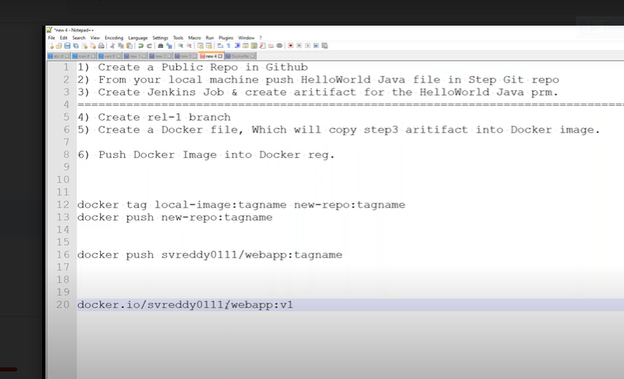

Docker tag image1 9573396992/webapp:v1

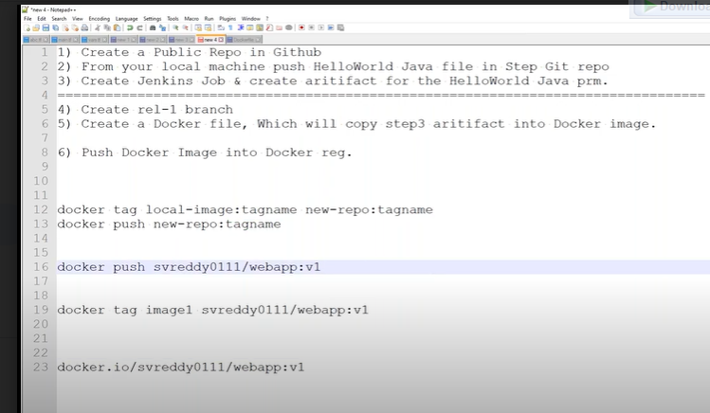

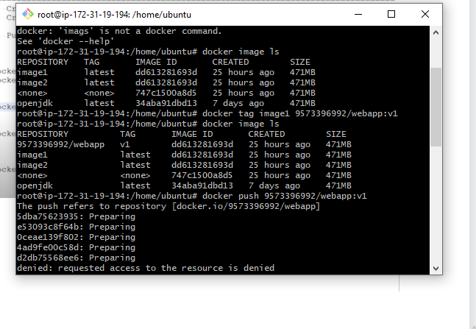

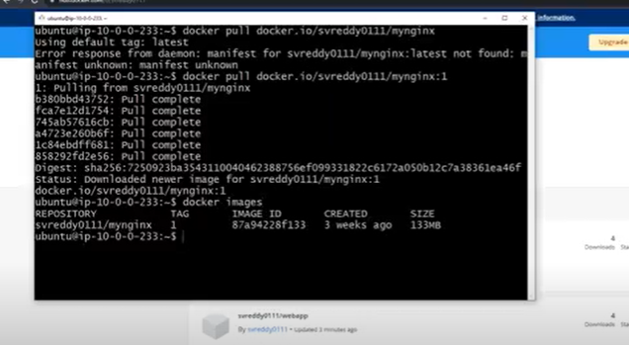

Based on the url docker designed.

1. Devloper create a application
2. Create a artifact
3. Create a docker file then copy the artifact into docker file
4. Build the docker file to image
5. Push that image to the docker reg.

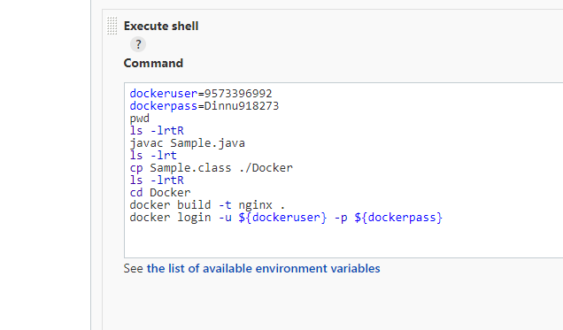

We have to put cred not here we have manage creditians page we have to configure in jenkins

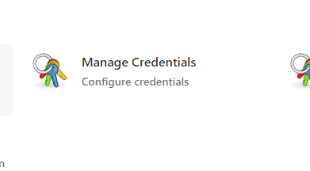

70th video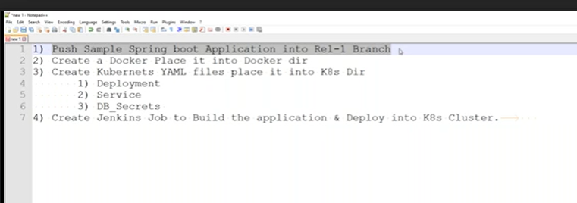

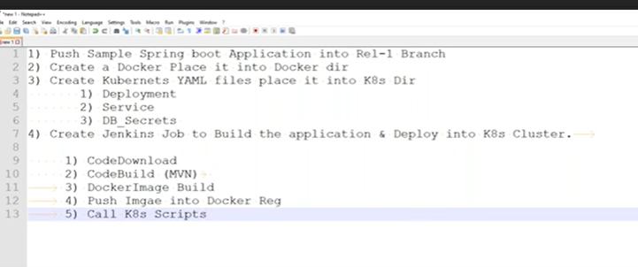

Jenkis integated

Git=====for integated with git jenkist server need to install git software

Docker registry---------for docker softer

K8s cluster.---------kubctl need to install

Jenkis conn with k8s cluster what is required

In 100 k8s cluster’s are there how jenkins connected with particular cluster

When k8s installed in one server in user home dir .kube dir insdie kubeconfigfile inside that file having the which server is conneted that is we can call it as certificat’s

/etc/kuberinities/admin.conf

Setup:

1. jenkins server
2. K8 server

=

Wt is ddiff bet local-exec & remote excution

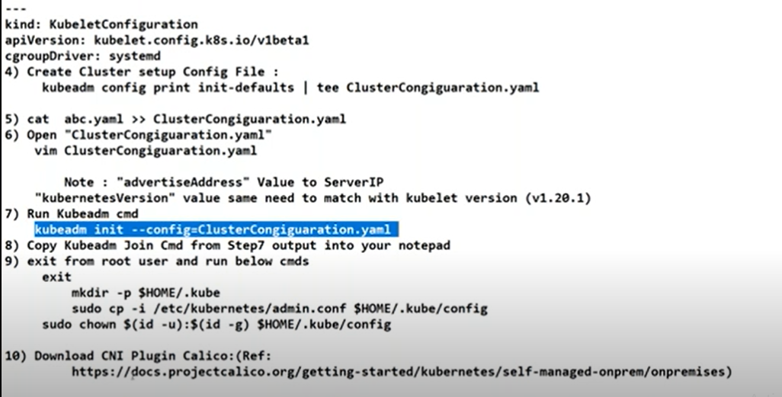

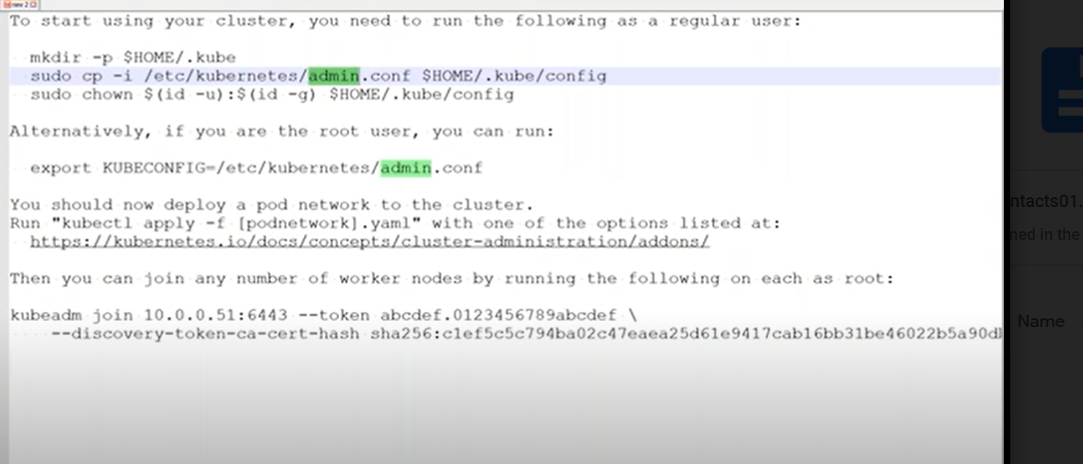

Inside jenkins server need to have admin.conf file

So mauvally push certificate’s into github

Master setup complted

Worker node’s completed

Check kubectl get nodes

Upto k8s set up done

See in notepadd data

Jenkins server connte to k8s cluster in jenkins server have k8s admin.conf file

1. I want to download image from docker private registery

Terraform script’s

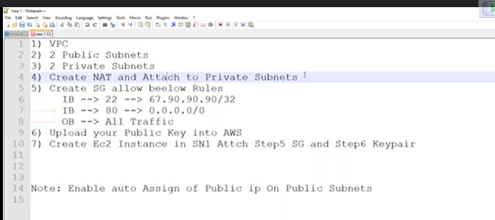

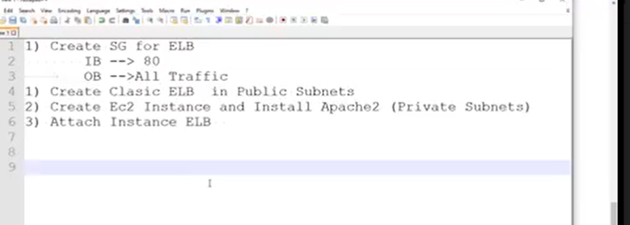

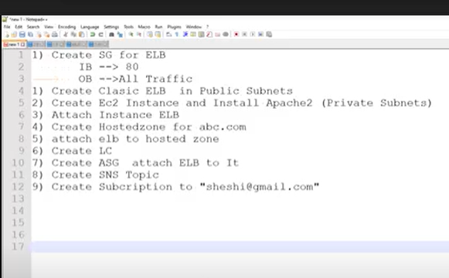

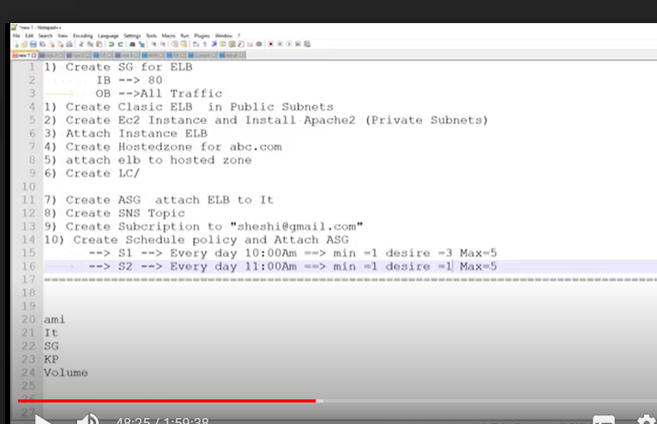

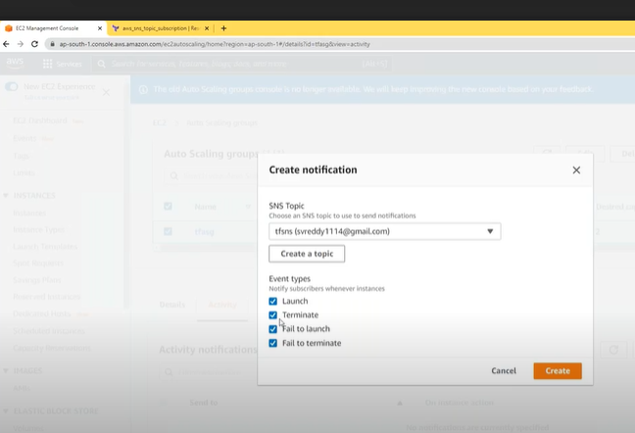

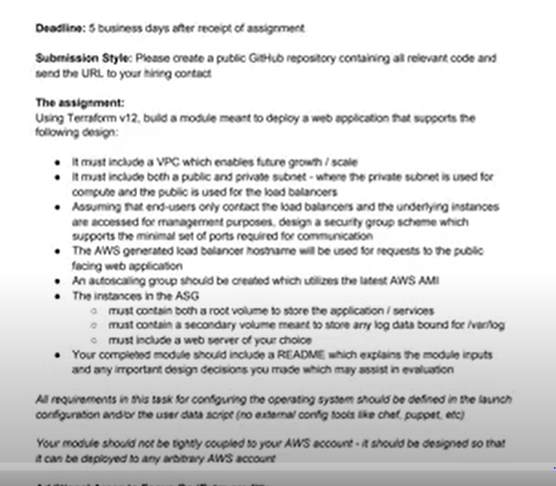

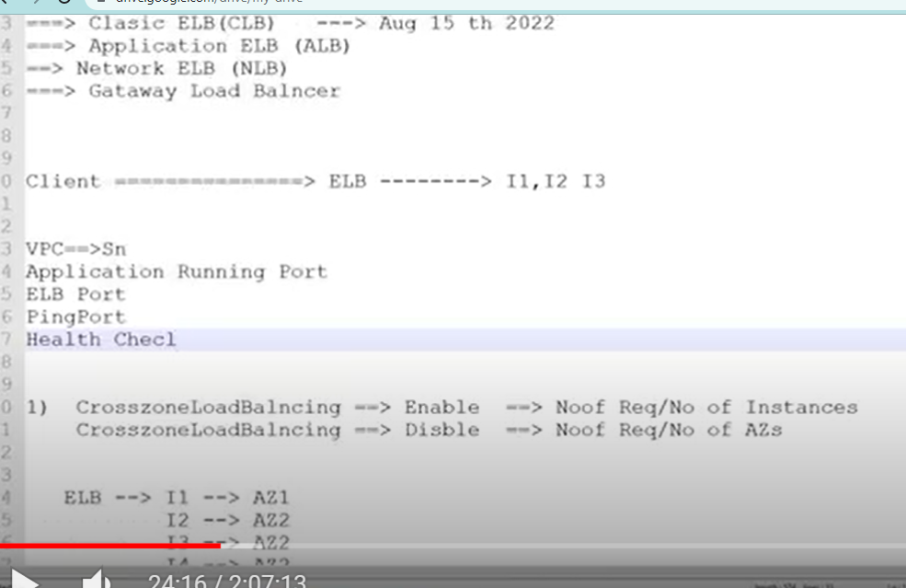

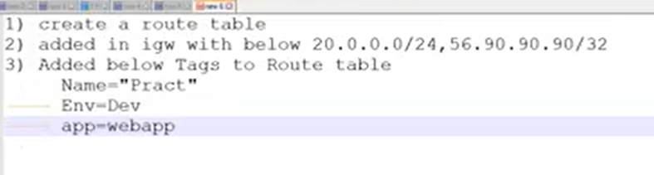

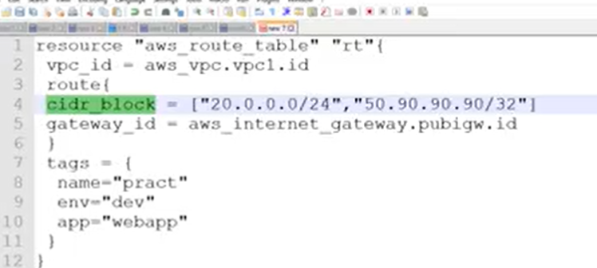

Above rong

Below correct

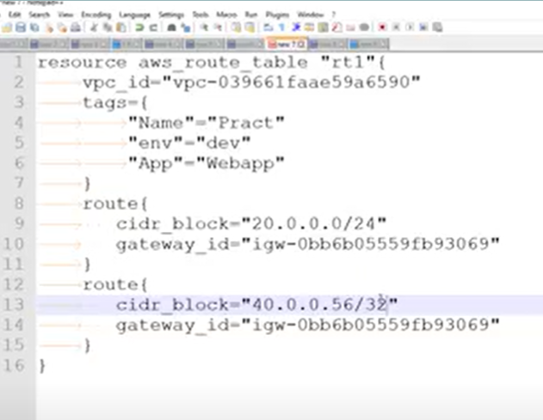

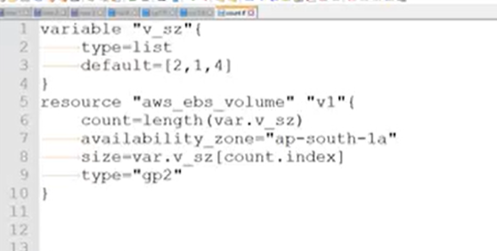

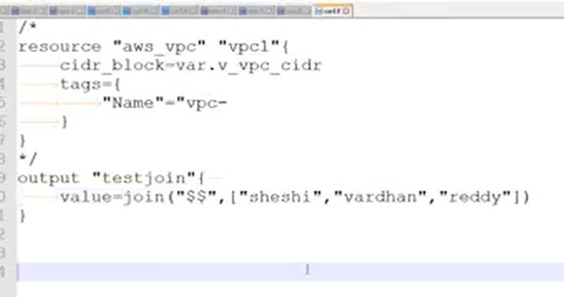

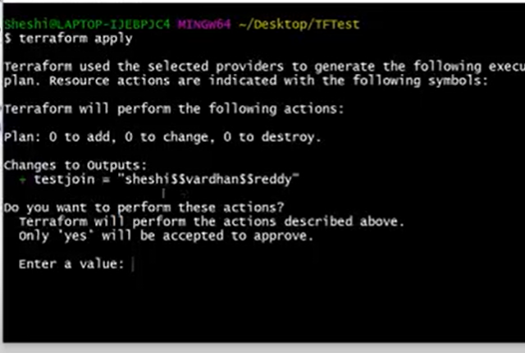

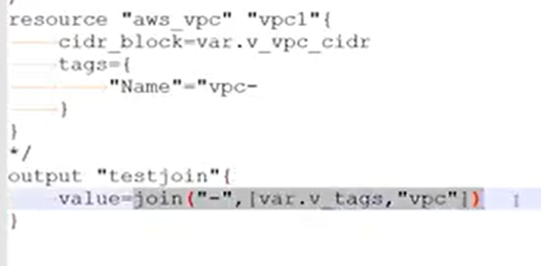

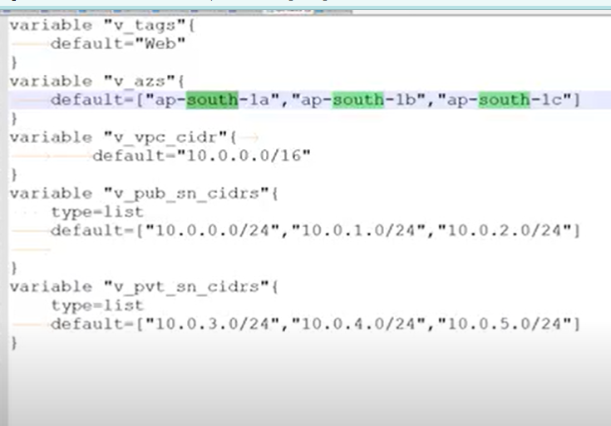

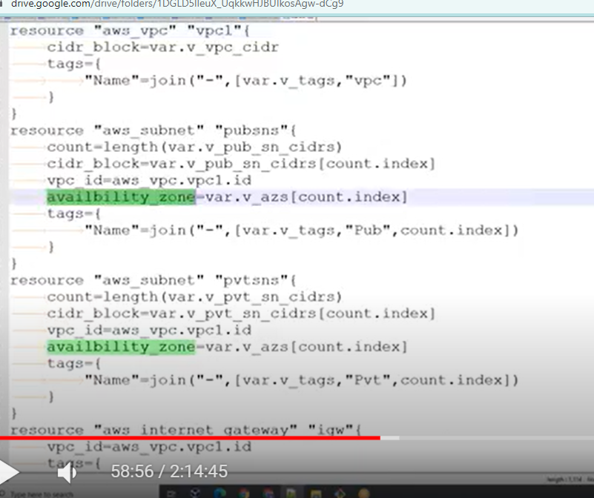

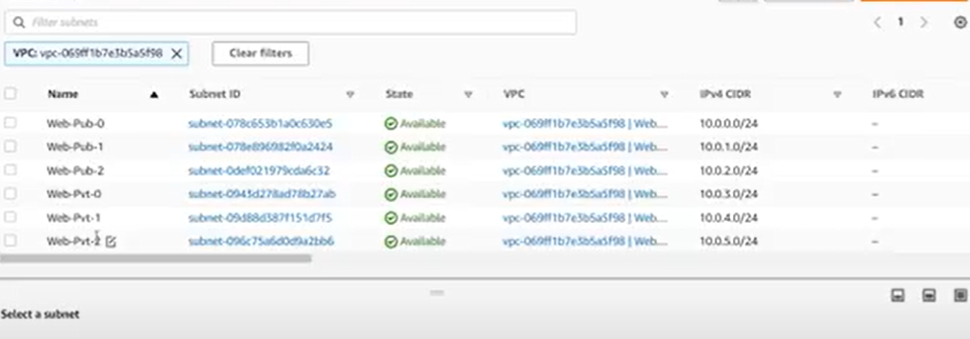

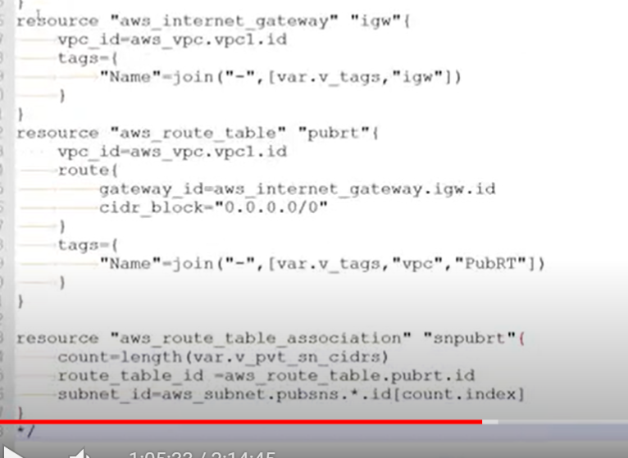

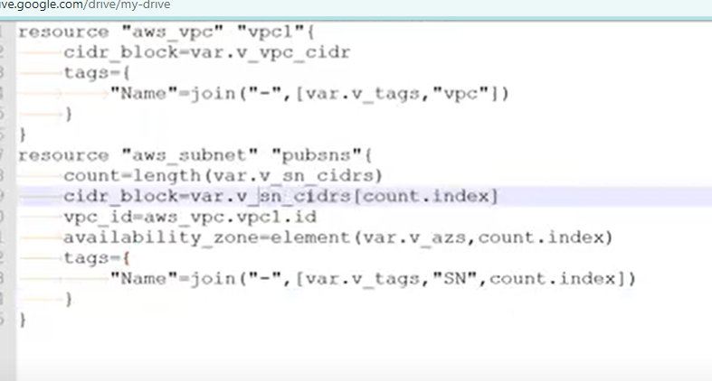

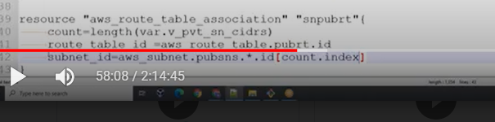

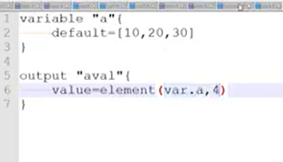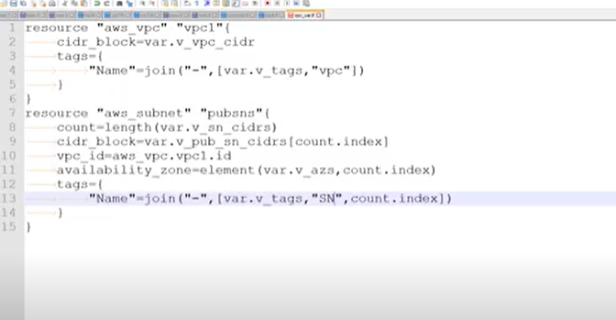

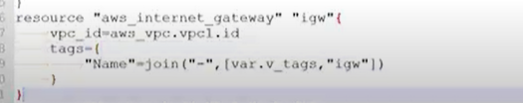

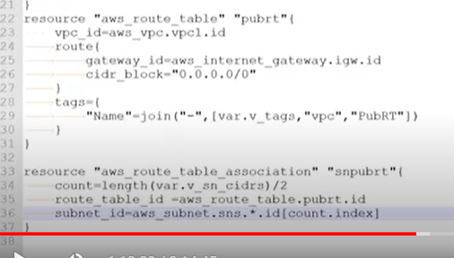

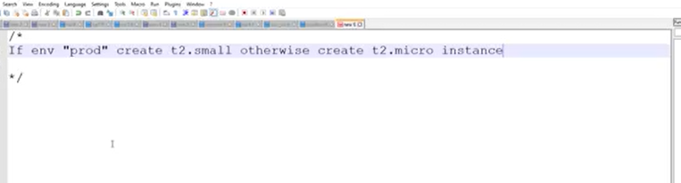

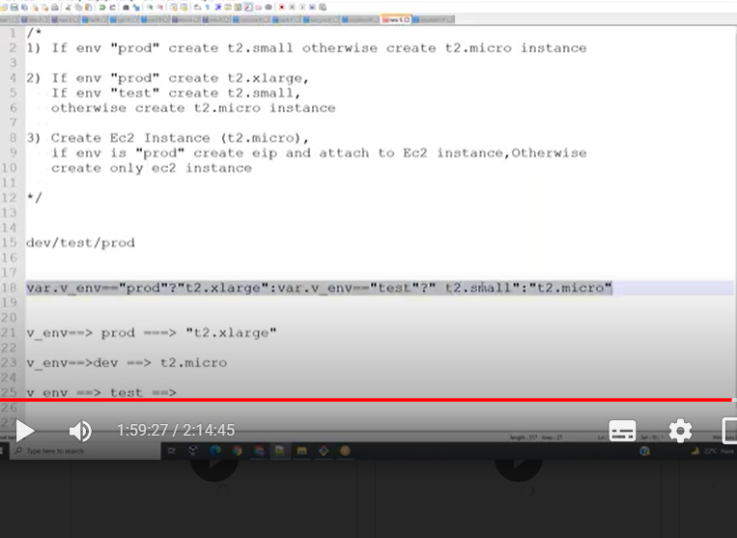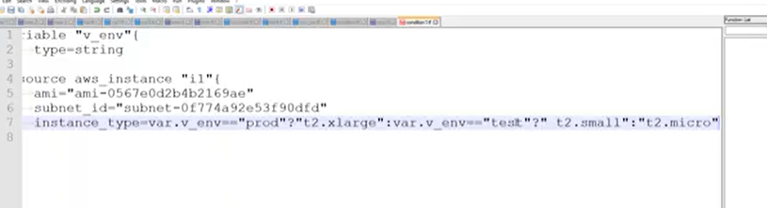

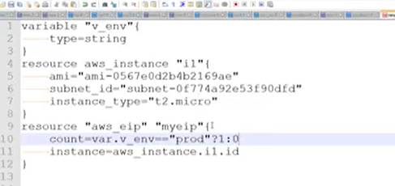

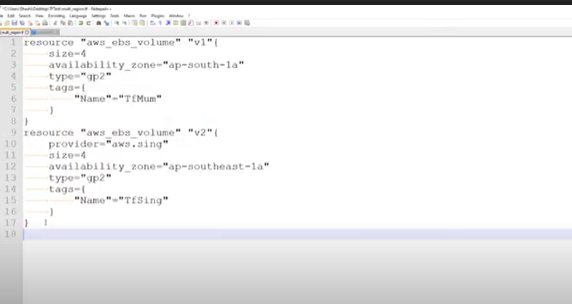

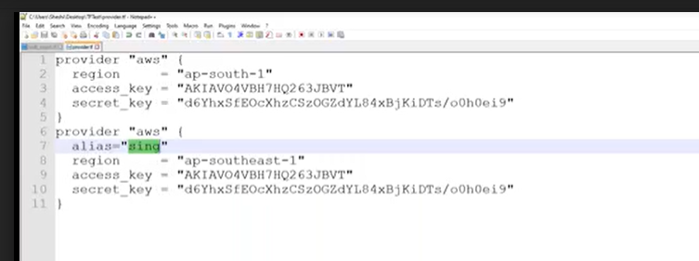

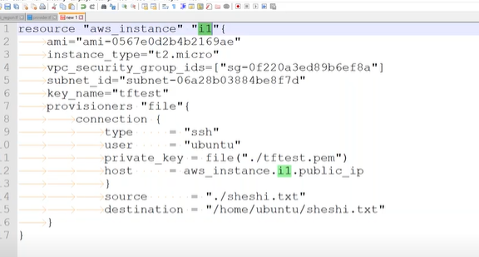

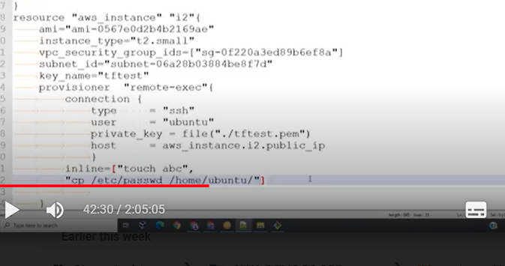

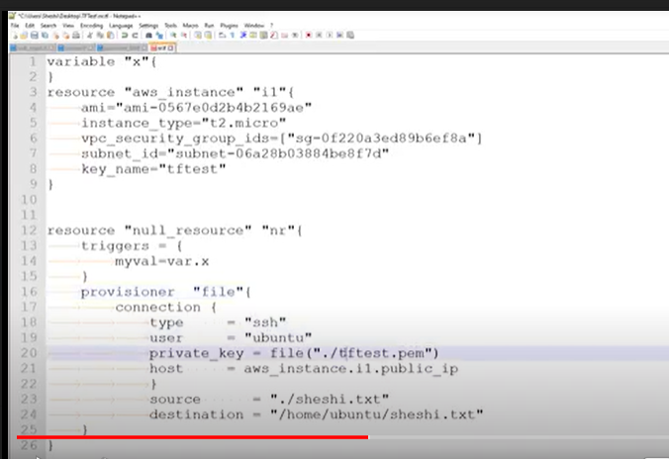

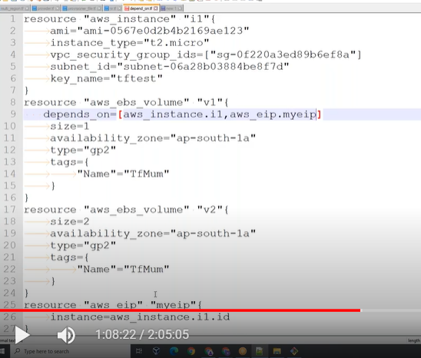

Dependes_on

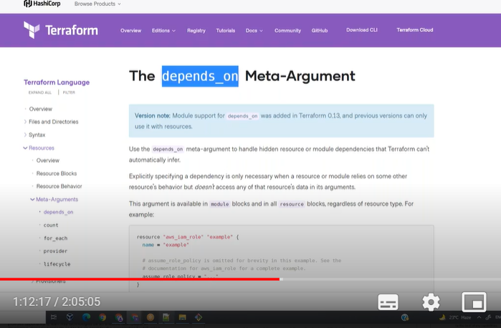

This above parameter’s wiill came from 15 onward’s

